

Sri Lanka Institute of Information Technology

Bridal, Beauty Salon & Academy Management System

Software Requirement Specification

Information Technology Project 2016

Project ID: ITP-16-METRO-WD-B2-G5

Submitted by:

1. IT15102560 – De Silva S.S.R.D.M.
2. IT15127174 – Ranasinghe R.A.N.I.
3. IT13045722 – Athipola R.W.S.K.
4. IT15134936 – Kumarasiri S.D.D.C.
5. IT15127938 – Ratnayake R.M.T.U.
6. IT15134554 – Chathubashini N.D.J.
7. IT15134240 – Kahaduwa K.K.U.S.
8. IT15140562 – Dolawatta I.H

Submitted to:

…………………………..

Mr. S.M.B.Harshanath
01-August-2016
Table of Contents
Table of Contents i
Revision History i
1. Introduction 1
1.1 Purpose 1
1.2 Document Conventions 1
1.3 Intended Audience and Reading Suggestions 2
1.4 Product Scope 3
1.5 References 4
2. Overall Description 5
2.1 Product Perspective 5
2.2 Product Functions 6
2.3 User Classes and Characteristics 7
2.4 Operating Environment 9
2.5 Design and Implementation Constraints 10
2.6 Project Documentation 10
2.7 User Documentation 10
2.8 Assumptions and Dependencies 11
3. External Interface Requirements 12
3.1 User Interfaces 12
3.2 Hardware Interfaces
3.3 Software Interfaces
3.4 Communications Interfaces 25
4. System Features 26
4.1 Handle Appoinments 27
4.2 Salon Services 28
4.3 Bridal Services 29
4.4 Employee Management………………………………………………………………..30
4.5 Course Management…………………………………………………………………..32
4.6 Student Management………………………………………………………………….33
4.7 Inventory Control……………………………………………………………………..34
4.8 Financial Management………………………………………………………………..
5. Other Nonfunctional Requirements 6
5.1 Performance Requirements 6
5.2 Safety Requirements 6
5.3 Security Requirements 6
5.4 Software Quality Attributes 6
5.5 Business Rules 6
6. Other Requirements 7
Appendix A: Glossary 8
Appendix B: Analysis Models 9
Appendix C: To Be Determined List 10

Revision History
Name | Date | Reason For Changes | Version

Introduction

Purpose
This Software Requirements Specification (SRS) provides a detailed description of all the functions and constraints of Bridal, Beauty Salon and Academy Management System for “Hasini Gunesekara Salon’s Pvt Ltd”. The document highlights the drawbacks and the difficulties faced by the current manual system and the solution introduced by the development team in order to overcome the problems facing by the client currently.
The document includes of the purpose, the scope of the project, a description of the main features of the system and the interfaces provided to these features, the constraints under which it must operate and how the system will collaborate with the end users of this system. This document is intended for both the stakeholders and the developers acting as a legal hand between the client and the development team providing an assurance that the final product would meet all the requirements that are mentioned in the SRS.

Document Conventions
- Font - “Times New Roman”
- Font size - 12 pts
- Line spacing – 1.5
- Format - IEEE
- HGS (Pvt) (Ltd) – Hasini Gunesekara Salons’ Private Limited
- Libraries and Tools - Relevant components needed for the software’s which are used to create the system.
- Java - A computer programming language
- MS SQL - Piece of software which is used to create and manage database
- NetBeans IDE - Piece of software which is used to create Graphical User Interface
- iReports – A report generation software

Intended Audience and Reading Suggestions
The entire system contributes to the overall functionality of the system. The completed system will have the capacity of the overall manual system in every aspect, with attractive graphical user interfaces which are capable of being easily handled.
The expected audience of this document includes the Administration and High Authorities of the HGS (Pvt.) (Ltd), The Users of the HGS (Pvt.) (Ltd), Supervisors and The Development Team including software developers, project managers, testers and document writers etc.

- Administration and High Authorities of the HGS (Pvt.) (Ltd)
Suggested Reading -:
- Chapter 4 -System Features
- Chapter 5 -Other Non-Functional Requirements
- Chapter 3 -External Interface Requirements
The administrator needs to analyse in detail if the functional requirements of the system are exactly represented in this document. If not, it has to be immediately informed to the developing team without further delay.
Chapter 5 discuses, in detail, the other attributes and features of the proposed product including qualities, constraints and other performance requirements. The Administrator needs to ensure that the developing team has understood the institute’s method of operation and its operational constraint.
- The Users of the HGS (Pvt.) (Ltd)
Suggested reading:-
- Chapter 3 -External Interface Requirements
The primary users of the system need to have an idea of the interfaces they will be working with and suggest any new methods to the developing team to make their tasks easier or more user-friendly.

- Supervisor of the project
Suggested Reading:-
- Chapter 1.4 -Product Scope: The supervisor may require confirming if the scope of the project meets the academic requirements of the course.
- Chapter 3 -External Interface Requirements: The supervisor may need to ensure that the system is developed in a standard manner.

- Developers of the system.
Rest of the SRS contains overall description that describes productive functions, user classes, operating environment, design and implementation, external interface requirements that describes all interfaces in the system.

Product Scope
Hasini Gunasekera Salon's (Pvt) Limited is Sri-Lanka's pioneering Bridal, Beauty salon & Academy founded in 1978. They have become a trusted name for elegant brides.
Currently the company is running with an issue of keeping track of records, handling financial area, and transaction processing manually. After analyzing gathered requirements, it was decided to implement a system to handle their work efficiently and more conveniently.
To manage the difficulty of Data Handling, the system maintains database backups and delete, edit and update functions on where necessary. Furthermore, the interfaces will be in a well-planned structure where the user has all the possible actions of a specific task in one place.
Product deliverables:-
- Employee management
- Course management
- Student management
- Handling appointments
- Inventory handling
- Financial management
- Wedding services
- Salon services and treatment handling

Objectives & Goals:-
- Provide the client an automated system to deal with their daily processes efficiently.
- Increase the accuracy in financial handling and transaction processing.
- Save users’ time by automating and reducing unnecessary paper work.
- Handle appointments effectively.
- Review students’ progress in student management.
- Give fast access to data.

References
<List any other documents or Web addresses to which this SRS refers. These may include user interface style guides, contracts, standards, system requirements specifications, use case documents, or a vision and scope document. Provide enough information so that the reader could access a copy of each reference, including title, author, version number, date, and source or location.>

Overall Description

Product Perspective
Gorgeous Salon & Academy System’s main purpose is to uplift business Quality by Creative & efficient software product. To success that purpose we replace paper process , improve efficiency of staff , streamline business operations and accounts and communicate more effectively with customers The system will have different access levels for the employees to work this feature ensures the security of the data .Also There is Student access level for academy and another access level for customers . The system will also be capable of creating various reports according to the needs of the company.

The major components of the system are show in the figure 2.1.1.
Handling appointments
Course Management
Student Management
Employee Management
Salon services

Financial Management

Bridal services

Database

Figure 2.1.1: Major Components of the system

Product Functions
The Main functions of the system have sub parts, which are:

- Handle Appointments
- Check availability
- Check special offers regarding previous customers

- Course Management
- Check whether the student limitation exceeds for each courses
- Check hall availability and course resources

- Student Management
- Register new student
- Searching and updating student details(register, grading, payments and attendance details)
- view student progress report according to their grading

- Employee Management
- Searching and updating employee details
- Calculation of working hours of each employee
- Check availability of employees

- Salon services
- Get customers feedback for Salon services
- Patch Testing

- Financial Management
- calculating currency inflow and outflow
- Tracking all bill payments

- Bridal services
- Customize wedding packages
- Maintain Gallery
- Calculate the total amount of customize wedding packages
- Add , Updating & delete default package details
- Get customer feedback
- Add, delete and update Customize wedding packages and prices
- Print wedding packages details

Search default wedding packagesUser Classes and Characteristics
User Type | Frequency of use | Educational/  Experience Level | Accessible functions
Manager | High | - 10 year working experience as Manager | - Handling employee details.  - Inventory control and Purchasing.  - Generate Reports  - Handling all the cash inflows and Outflows.  - Make default bridal packages & salon packages  - Supervise customized packages
Accountant | High | - Full qualification in AAT/ HNDA/ ACCA/ICA/CIMA  - Minimum 1 year experience in the same field with audit exposure | - Calculating currency inflow & outflow  - Make bill payments
Receptionist | High | - Possess the qualification of GCE O/L, A/L  - Knowledge Of Basic computer Operations  - Minimum 1-2 years’ experience in the similar capacity  - Fluent commanding in English and Sinhala | - Handle Appointments
Lecturer | Medium | - complete a certificate or degree program in cosmetology, aesthetics or another specialty  - Teaching skills  - Minimum 2 years’ experience | - Update Lecture Status, Tutorials.
Beautician | Medium | - complete a certificate or degree program in cosmetology, aesthetics or another specialty | - Patch testing  - Handle treatments
Computer Operator | High | - Minimum 1 year experience in same field  - Complete certificate level of IT program. | - Check hall availability and course resources  - Check availability of employees  - Searching and updating employee details  - Calculation of working hours of each employee  - Searching and updating student details  - Check availability of employees
Customer | Medium

Operating Environment
The system will operating in windows environment. The software will operate with the following hardware platform, operating system and versions,
- Computers with 2GB Ram ,1.5GHz or above
- Dot Matrix printer (for slips)
- Laser printer (for reports)
- Barcode Reader
The software required for successful implementation and the required software needed for efficient usage are listed below. The following list contains the minimum software requirements.

Software for implementation:
    - Java Development kit 8
    - Java Runtime Environment 8
    - Netbeans 8.0
    - Adobe Photoshop CS6
    - My SQL Server 5.5 or above
    - I-reports
    - Microsoft Windows 7 or above
Software for usage:
    - Java Runtime Environment 8
    - My SQL Server 5.5 or above

Design and Implementation Constraints
The proposed system was initially planned to be implemented as eight independent subsystems.

- Database needs to be available to internal sources for queries. MYSQL server will be used as SQL engine and database.
- Login and password is used for identification of user.
- GUI use for interfaces.
- All coding will be doing in java.
- Only registered owner, manager, accountant and beautician will be authorized to use the services.

Project Documentation
The introduction to the system will be presented as project documentation. This will help any new member understand the overall purpose of the final product. The Software Requirement Specification will be also presented so that a thorough comparison can be done to verify whether the actual plan has been carried out and to understand how complete the final product will be. Since the database management is a vital part in the system the overall entity relationship diagram will also be presented along with other documentation to get the basic fundamental overview of the database creation and maintenance.

User Documentation
<List the user documentation components (such as user manuals, on-line help, and tutorials) that will be delivered along with the software. Identify any known user documentation delivery formats or standards.>

Assumptions and Dependencies
- It is assumed that the Salon will have enough trained staff to take care of the system.
- All the entered data will be correct and up to date.
- Need MYSQL server to store the database.

External Interface Requirements

User Interfaces
This content includes the basic structure of the interfaces that have been designed for system, and a brief description about the use of each one of those interfaces.
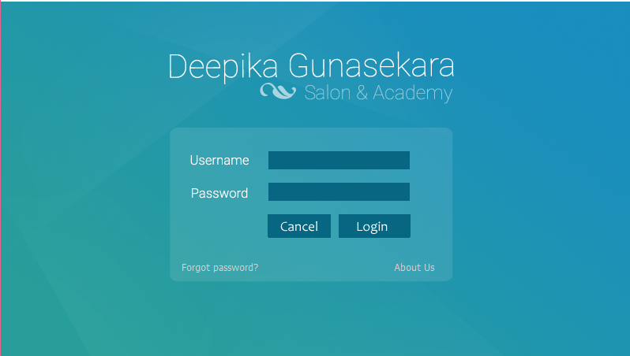
This is the Main login to the system. This will be the first interface anyone trying to access the system will see.

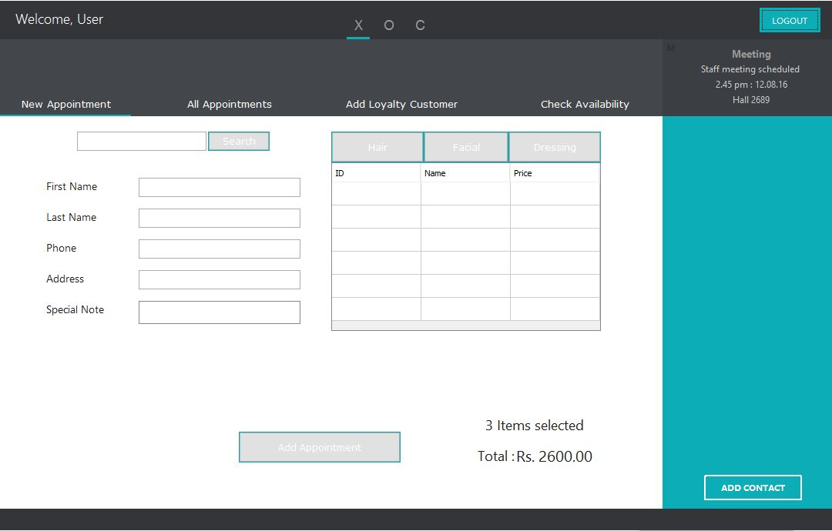
This interface is used to add new appointments by the Receptionist. Receptionist can press logout button if she wants to log out from the system.

This interface is used to add Loyalty Members to the system. Customer details are taken and fed into the System and a unique ID to each customer assigned automatically, which can be used to refer to a specific customer for further processing and to be used in other functions.
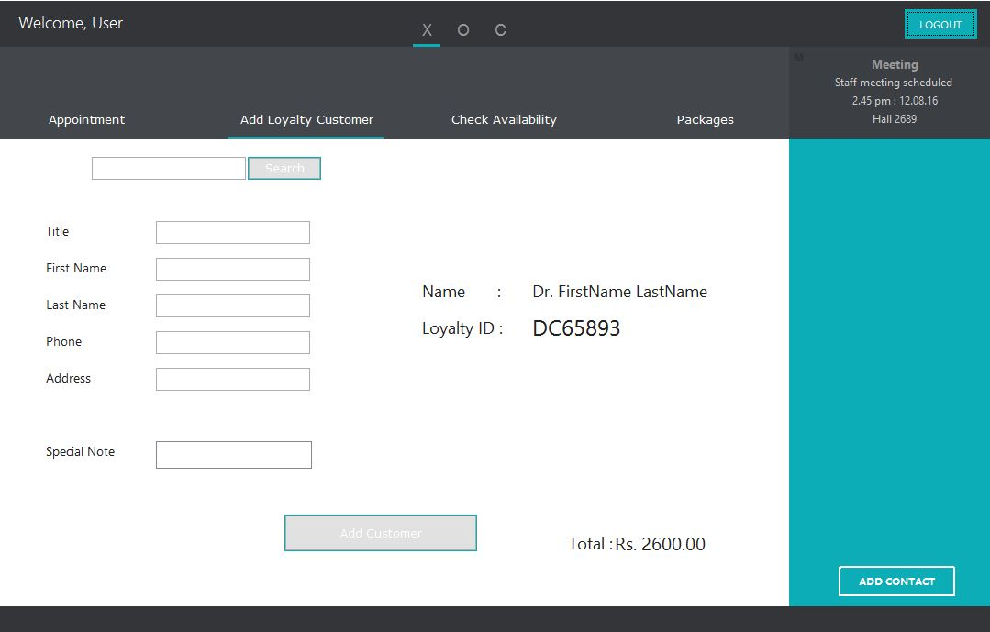

This is the main page for admin if he selects the manage Students Details option. Through this interface admin can get access to various forms like Register Student, View Attendance, View and Add Grading etc.
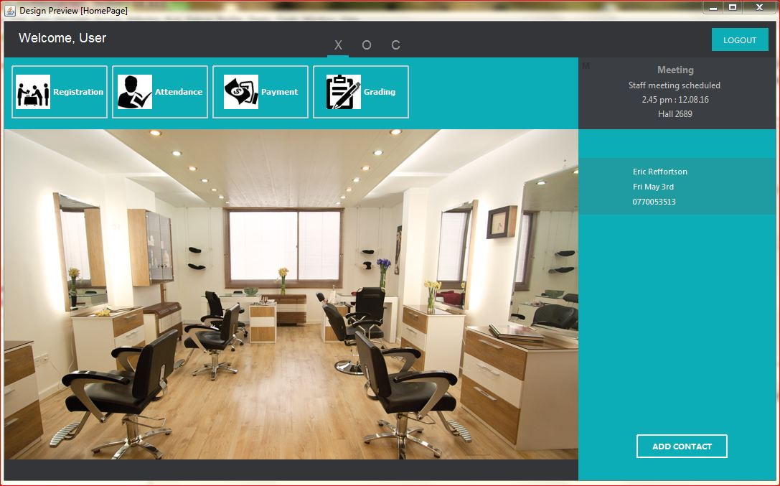

This Interface is used for add new students to the system in the academy. Relevant details are added to the fields and fed them into the database by clicking add button. By clicking cancel button all the fields can be cleared to add a new student.

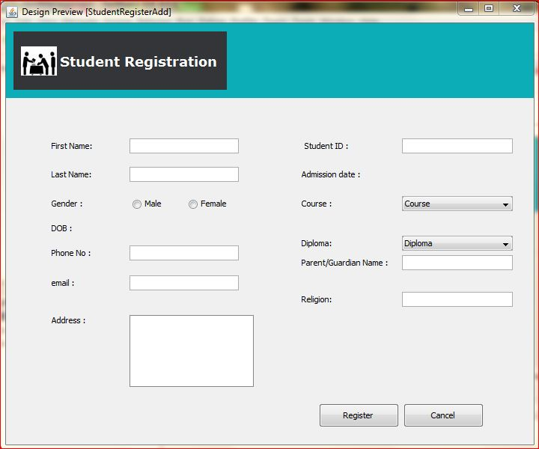

This view is used by the Manager to add new Employees. By adding “Add Employee” button all the details of the employee can be stored in to the database. Manager can view notifications from right side bar which is colored in light blue. Manager can view reminders like meetings black square which is on the top right corner.

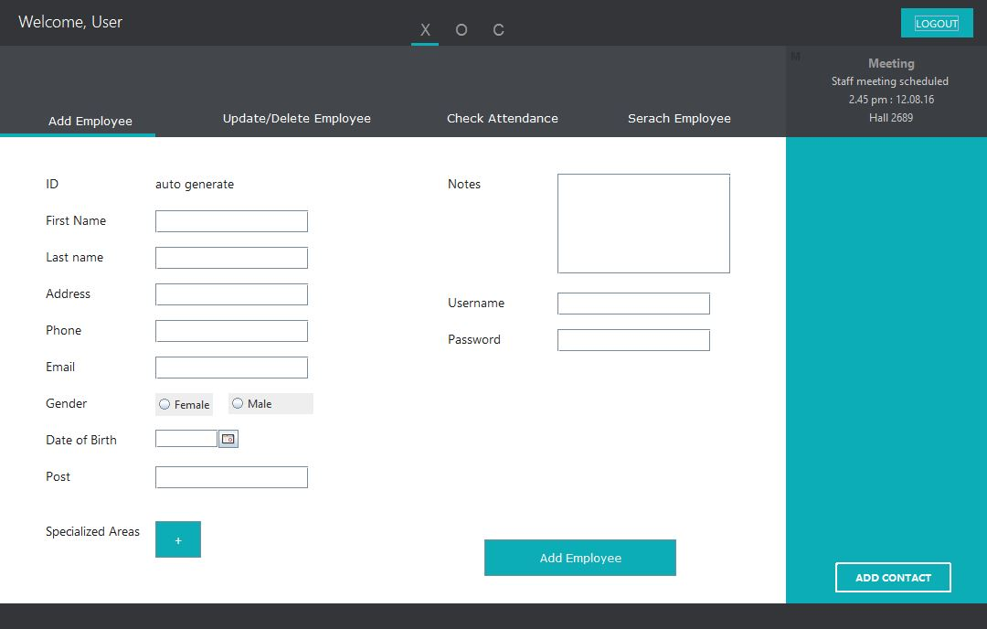

This interface is used to search employees. By clicking search button, after adding employee id or employee name employees who have similar names and ids are appeared on the table. If the manager selects an employee from the table and clicks “View Full Details” button manager can view all the details about that employee. If manger clicks “View Full Attendance” button he can view attendance details about that selected employee.

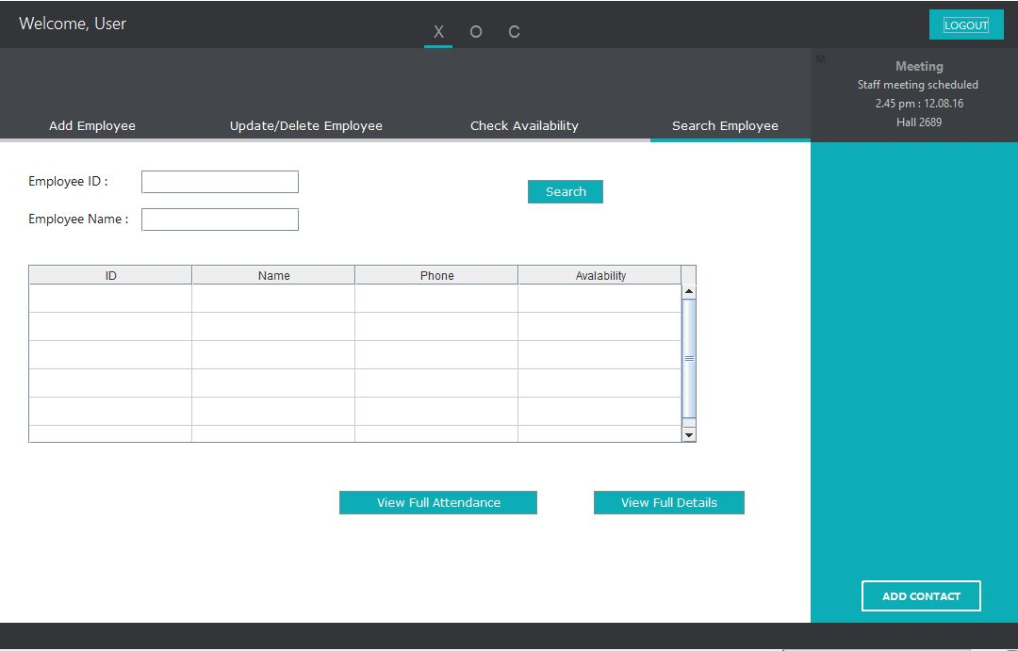

This interface is used for two tasks. Left side part which is in blue color is used to add (register) new treatments. Right side part which is in white color background is for update or delete treatments. After searching for treatments by its ID manager can select and delete or update that treatment.

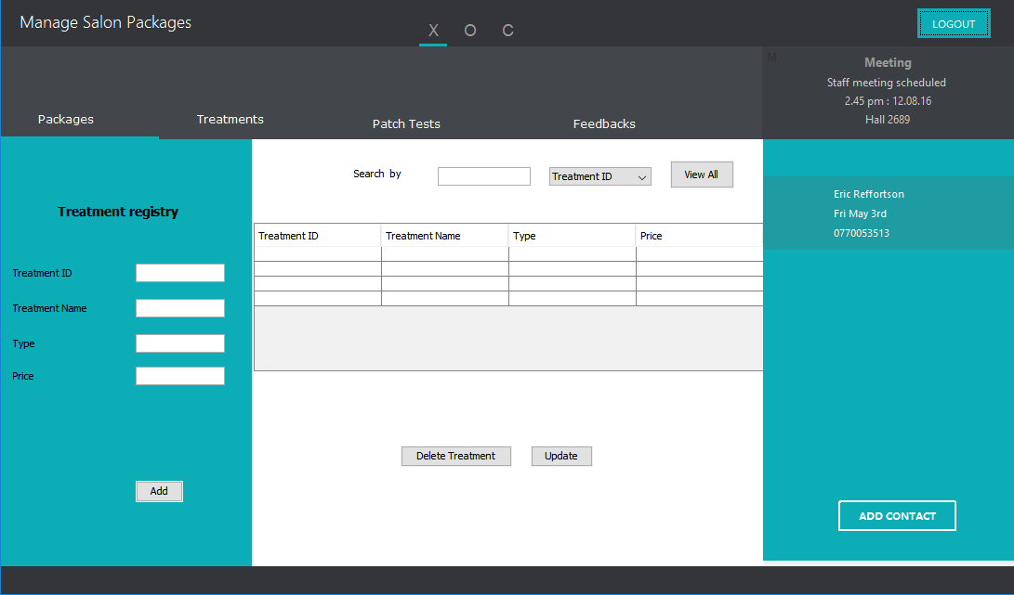

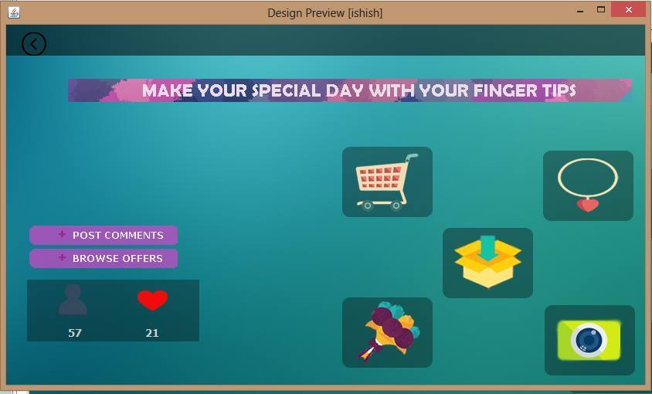

This panel displays some of the functions available under the Course Managements.
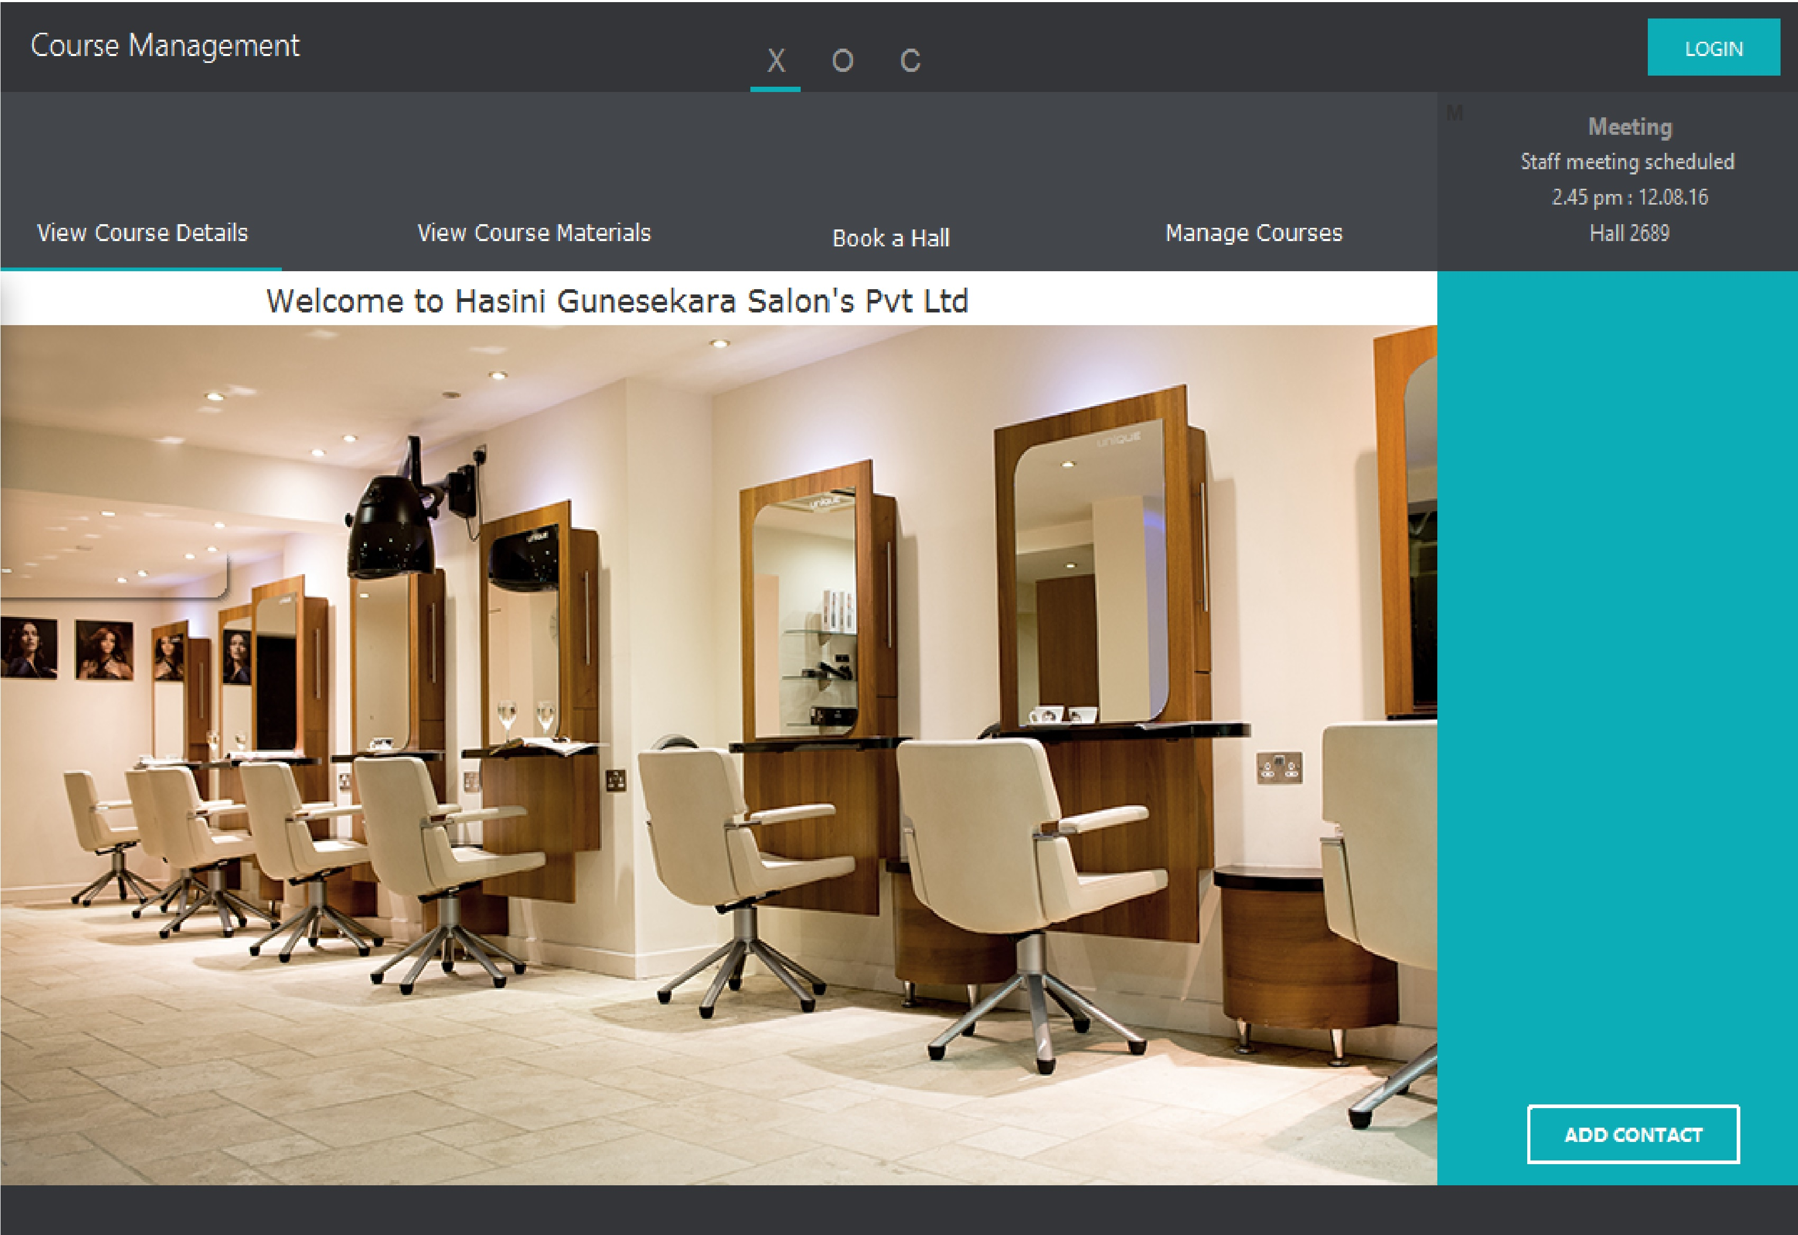

This interface is used to do tasks related to manage courses function. Mainly add, update, delete and
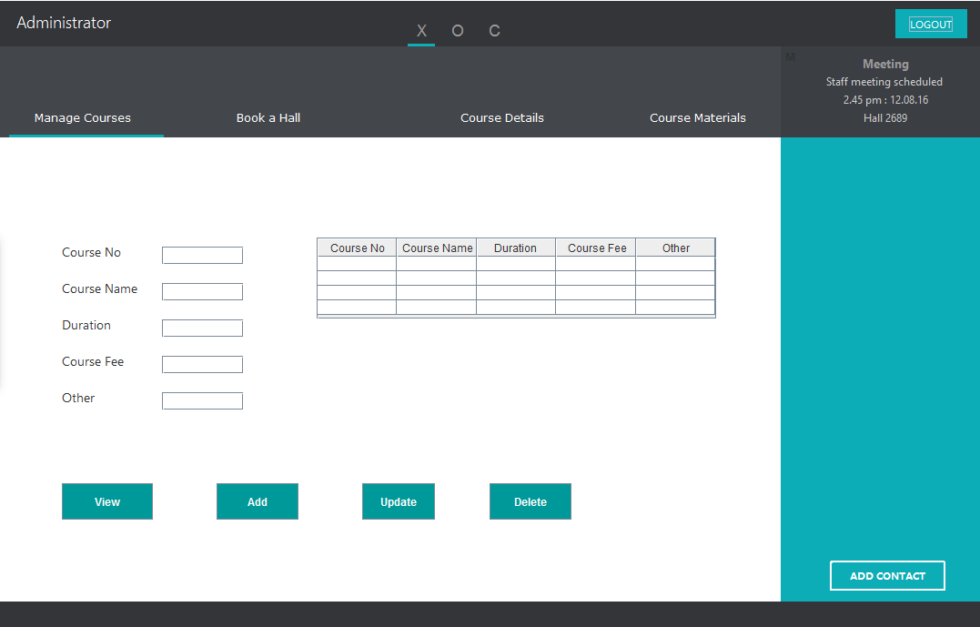
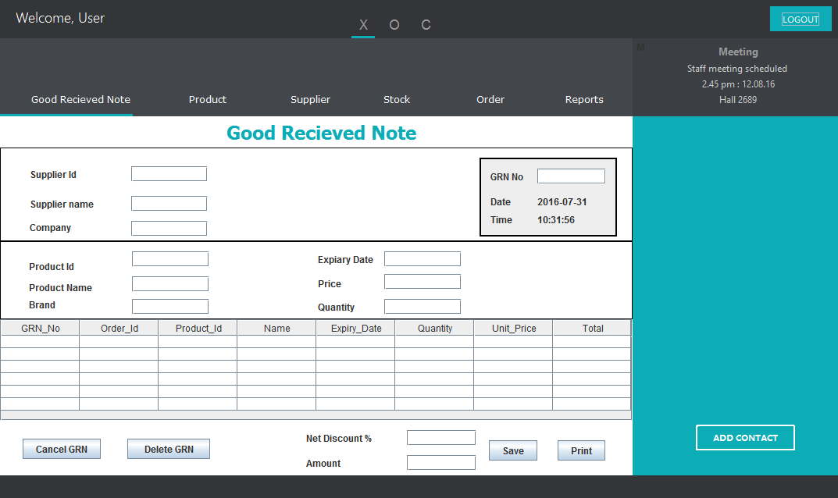
This interface is used for insert details about Good Receive Note on products to the system.

This interface is to add new products and view product details..
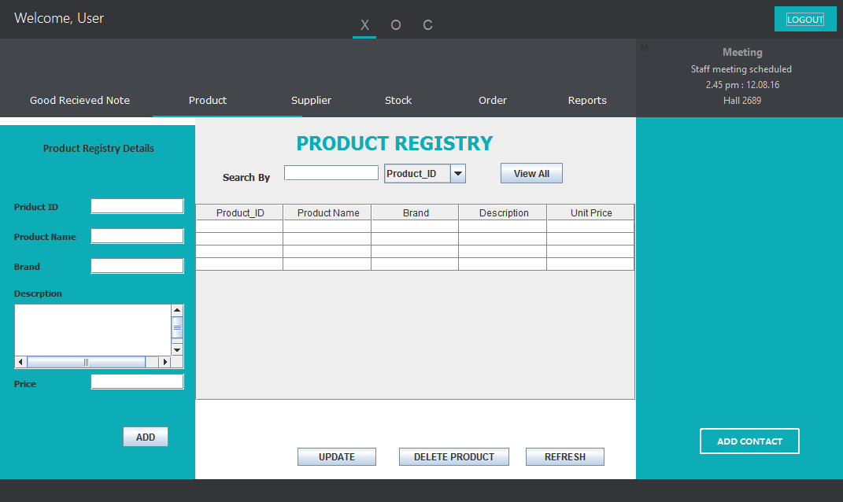

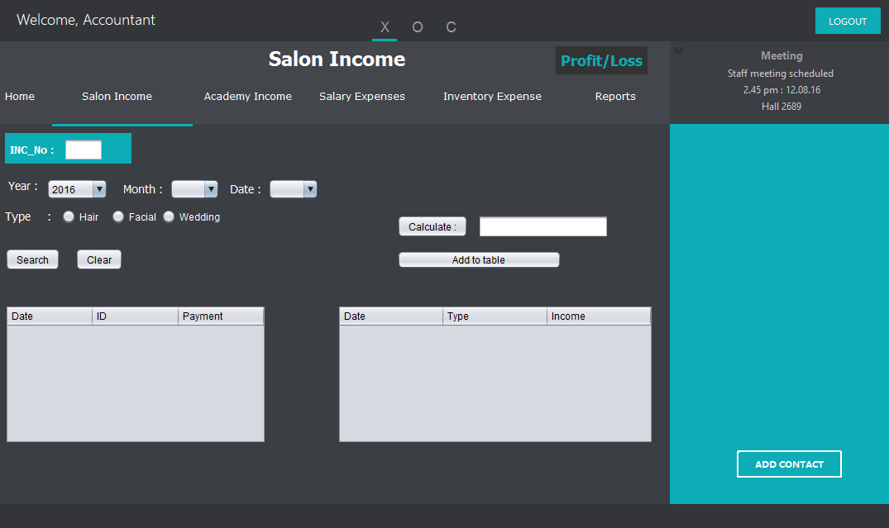
This interface is used to retrieve income information for a specific treatment category for a given date.

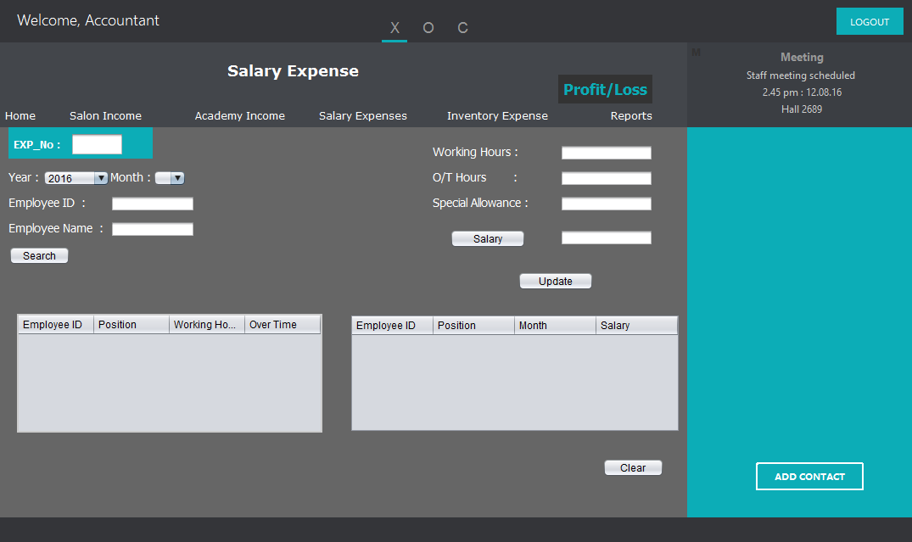
This interface is used to calculate salary for each employee in monthly basis. This calculation depends on working hours, O/T hours, Special allowances.

Hardware Interfaces
The system will be installed in a computer. The computer should have at least Intel® Dual Core or Higher Processor, 2GB of RAM, a Network Interface Card, 100GB Hard Disk and a color display with 1024 x 768 screen size for users to access the system.
Other than that the system associates with few external hardware devices. Dot Matrix Printer is needed to print the invoices, bills and other slips. Laser Printer is to be used for generating all the reports.
Bar code reader will be used to read the bar codes in cards which is given to every employee and student.

Software Interfaces
The system is to be implemented using Java Development kit 8 and Java Runtime Environment 8 in NetBeans 8.0. My SQL Server 5.7 is used to store employee, stock, student, finance and relevant other information related to the system. In designing Reports, I-Reports software will be used. Adobe Photoshop CS6 is used to design logos and other different images. The system will be installed in a Microsoft Windows Vista or above Operating system environment.

Communications Interfaces
The system is capable of only sending messages but is not capable of receiving messages back. In doing so the system will require a secure internet connection and the system will be registered under a local area internet service provider. Other than that basically the system will use the service of SMTP protocol. Through the system employee can do requests, like for shift appointments among beauticians, request for a leave and special offers for employees.

System Features

Use Case ID: | USC_00
Use Case Name: | Login to the System
Brief Description: | This use case describes how an employee logs into the system.
Pre-Conditions: | - User must have access to the system.  - User must be a previously registered employee with a valid username and password.
Post Conditions: | User get access to his/her account.
Primary Actor: | Employee
Main Flow of Events: | - Use case begins when the employee opens the software.  - System prompts for the username and password.  - Employee enters the username and password.  - Validate username and password.  - System shows the employee’s home page and displays message saying that the “Login is successful”.
Extensions: | 3) A) 1) If login is unsuccessful the system gives maximum of 3 times attempts.  2) If 3 times exceeded then ask user to reset the password.

Handle Appointments

Use Case ID: | UCS_01
Use Case Name: | Add Appointment
Pre-Conditions: | 1. Receptionist must have access to the system.  2. Receptionist must be a previously registered employee with a valid username and password.
Post Conditions: | Customer gets an appointment.
Primary Actor: | Receptionist
Main Flow of Events: | - include (Login to the System)  - Receptionist selects Appointments tab.  - Receptionist selects ‘Add Appointment’ option  - Receptionist inputs customer name, phone number and address.  - Receptionist clicks add appointment button.  - System gives appointment successfully added message.
Extensions: | 3) A) 1) If login is unsuccessful the system gives maximum of 3 times attempts.  2) If 3 times exceeded then ask user to reset the password.

Use Case ID: | UCS_02
Use Case Name: | Add Loyalty Customer
Brief Description: | This use case describes how the receptionist can add customer details to the system.
Pre-Conditions: | - Receptionist must have a valid employee account.  - Receptionist must successfully log in to the system.
Post Conditions: | New loyalty customer’s details are added to the system.
Primary Actor: | Receptionist
Main Flow of Events: | - include (Login to the System)  - Receptionist selects the Handle Customers option.  - Receptionist clicks the ‘Add Loyalty Customer’ tab  - System auto generates a valid and meaningful customer id and display it on add loyalty member form.  - Receptionist add necessary customer details to the relevant fields in the form (Name, Address, Date of Birth, and Contact Number).  - Receptionist clicks Add button.  - System validates information entered by the operator.  - System displays message saying “Customer Details are added successfully.”
Extensions: | 5) A) 1) If details entered by the receptionist is not valid receptionist should re-enter the relevant information again.

Salon services

Use Case ID : | UCS_03
Use case name : | Manage salon packages
Preconditions : | The user has the correct username, password and the edited package details
Post-conditions :
Primary actors : | Manager
Main flow of Events : | Step | Action
Main flow of Events : | 1 | User login to the system
Main flow of Events : | 2 | User add/update/delete salon packages
Main flow of Events : | 3 | Successful/ failed notification is displayed

Bridal Services

Use Case Id : | UCS_05
Use case name | Handle treatments
Preconditions : | The user has the correct username, password and treatment details
Post Condition : | Successful/ failed notification
Primary actors | Manager
Main Flow of Events: | Step | Action
Main Flow of Events: | 1 | User login to the system
Main Flow of Events: | 2 | User add/update/delete treatment details
Main Flow of Events: | 3 | Successful/ failed notification is displayed

Use Case ID : | UCS_04
Use case name | Customize Wedding Packages
Pre-conditions : | The user has to make an appointment
Post-conditions : | User successfully submit the customized package
Primary actors | Receptionist, customer
Main flow of Events : | Step | Action
Main flow of Events : | 1 | User goes to the package customizing page
Main flow of Events : | 2 | User customize package by adding fetchers
Main flow of Events : | 3 | User Submit the customize package in to the system
Main flow of Events : | 4 | Record the package details and display submission status.
Extensions | 4a 1. If the Customized package submission are fail the system prompts user to re-customize packages.

Employee Management

Use Case ID: | UCS_06
Use Case Name: | Add Employee
Pre-Conditions: | - Operator must have a valid employee account.  - Operator must successfully log in to the system.
Post Conditions: | New Employee’s details are added to the system.
Primary Actor: | Manager
Main Flow of Events: | - include (Login to the System)  - Operator selects the ‘Handle Employee Details’ option.  - Operator clicks the ‘Add Employee’ tab  - System auto generates a valid and meaningful employee id and display it on add employee form.  - Operator add necessary employee details to the relevant fields in the form (Name, Address, Date of Birth, Contact Number, Post etc.).  - Operator clicks Add button.  - System validates information entered by the operator.  - System displays message saying “Employee Details are added Successfully.”
Extensions: | 5) A) 1) If details entered by the operator is not valid operator should reenter the relevant information again.

Use Case ID: | UCS_07
Use Case Name: | Search Employee
Pre-Conditions: | - Manager/Owner must have a valid employee account.  - Manager/Owner must successfully log in to the system.
Post Conditions: | Manager gets report showing graph about most selected treatments by the customers.
Primary Actor: | Manager, Owner
Main Flow of Events: | - include (Login to the System)  - Manager/Owner selects ‘Handle Employee Details’ option.  - Manager/Owner clicks ‘Search Employee’ tab.  - Manager/Owner enters employee id or name.  - System searches for that specific employee and views all the details about him/her.
Extensions: | 4) A) 1) If there is no such employee with the given id or name System displays message saying “Employee Not Found!!”.  2) Prompt Manager/Owner to reenter the employee id or name.

Course Management

Use Case ID | UCS_07
Use case name | View course materials
Preconditions | The user has the correct username and password
Post condition | The user successfully view the course materials
Primary actors | Student, Lecturer, Course Administrator
Main flow | Step | Action
Main flow | 1 | Include :: login
Main flow | 2 | User goes into the “Course Materials” page
Main flow | 3 | User view the course materials

Use case ID : | UCS_08
Use case name : | Arrange a hall
Pre-conditions : | The user is aware of the add/update/delete a hall booking
Post-conditions : | The user successfully add/update/delete a hall booking
Primary actors | Lecturer, Course Administrator
Main flow of Events: | Step | Action
Main flow of Events: | 1 | Include :: login
Main flow of Events: | 2 | User goes into the “Hall Type Selection” page
Main flow of Events: | 3 | User select a hall type : Lecture halls/ Practical halls
Main flow of Events: | 4 | User is directed to the “Hall Bookings” page
Main flow of Events: | 5 | User insert relevant details and press “Book/Update/Reset/Delete” button

Student Management

Use Case id : | UCS_09
Use Case Name : | Register Students
Pre-conditions : | Operator Successfully login to the system
Post-conditions :
Primary Actor : | Operator
Main Flow of Events : | 1. Operator login into the system successfully then display the homepage  2. Operator register students to the system by clicking register button  3. After operator can display register form then he enter details about particular student  4. System display successful message data are go to the database
Extension : | 1.a.If login details are not valid system display an error message  3.a.If Student details are not valid system display an error message

Use Case ID : | UCS_10
Use Case Name : | Manage Student Details
Pre-Condition : | Before Manage Student details Operator must register students to the system.
Post-Condition :
Primary Actor: | Operator
Main Flow of Events: | 1. For registered students operator can add his/her grading and attendance details  2. If operator want to view student register details, payment details, grading or attendance details operator must go to the home page relevant buttons and click search button  3. Then operator can search student by name or student ID
- Extension | 3.a.If student Id or name is not valid display error message

Inventory Control

Use Case Id : | UCS_11
Use Case Name : | Make Orders
Primary Actor : | Manager
Pre-Conditions : | Successful Login
Main Success Scenario  Flows : | - System displays all the options.  - System automatically generates notifications about low quantity stocks (below 10).  - In the order interface manager fills all the grids for placing an order  - The order will be sent to the supplier as an email.  - The order ID will be auto generated for each new order.  - A new record will be added to the order table in the database as pending order.
Extensions : | 4.1If the email hasn’t sent to the supplier; an error message will be displayed.

Use Case Id : | UCS_12
Use Case Name : | Add New Supplier
Primary Actor : | Manager
Pre-Conditions : | Successful Login  The supplier to be added to the system should not be exist in the database.
Main Success Scenario  Flows : | - The user is directed to the Supplier interface.  - Enter all required details about supplier to the respective fields.  - Click on Add Supplier button.  - System prompts successful message that record has saved.  - A new record will be added to the supplier table in the database and it will be displayed on the current supplier table in the interface.
Extensions : | 3a.1 If required fields are not filled display an error message to re-enter data.  3a.2 If entered data is not valid; the system prompts an error message.

4.2 Use Case Diagram

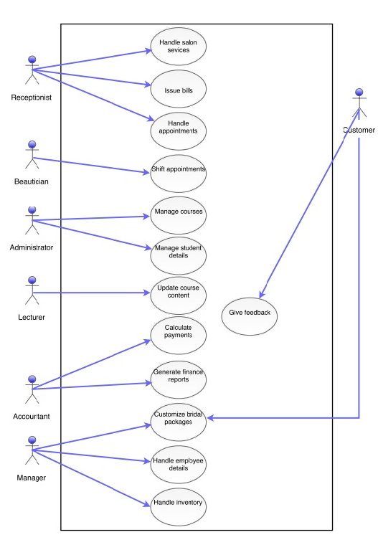

Other Nonfunctional Requirements

Performance Requirements
Despite the fact that the system is developed with standard performance, this performance is dependent on the performance of the hardware and software components of the installing computer.
Time taken to load the user interface would be limited only to a maximum of two seconds. Error messages should not take more than 10 seconds to be read completely. Verification for the login information take no longer than 5 seconds. User cannot choose more than one option form radio button option. Data loading from the System Database to an interface should be completed within 5 second.

Safety Requirements
This system has a software backup to maintain the reliability of the system. Before login to the system every user has unique username and password to enter to the system. According to the user login, system display different subsystem and also system provides error messages and display when data is not save in database.

Security Requirements
Login credentials are created for owner, accountant, operator and receptionist. Owner is the high privileged user of the system. Owner can access all the salon and academy functions. Operator handle the academic functions. Accountant has full responsibility for handle finance side. Receptionist handle the day to day appointment and issue bills.

Software Quality Attributes
Availability : The system shall be available during normal salon & academy operating hours.
Reliability : The System should regularly provide consistent results to the user queries.
Correctness : The System should provide correct and accurate results for the user’s various requests.
Usability : Ability of a software to offer its interfaces in a user friendly and elegant way.
Efficiency : Ability of the software to do the required processing on least amount of hardware.

Business Rules
- Receptionist can handle front office function such as take appointment and get payments
- Owner has ability to access any part of the system.
- Inventory can handle the manager
- Operator can handle the salon academy such as register student, course payments, marks attendance of student and keep track of student grading.
- Receptionist can get the special appointments but the owner will handle the special bridal services
- Accountant has ability to aces the finance part of the system

Other Requirements

1. Notification Bar
Important reminders for each user will be shown under this feature of the system with user friendly and in efficient manner. Such as give reminders about clients and notifications about stock shortage will be displayed in the notification bar for the relevant users.

2. Database backup and Restore
The privileged user has ability to protect the database against unexpected data loss and reconstruct and recover the database from any threat.

3. Help Centre
This feature is accessible for all users in the system. Help Centre is contained with the guidelines of how the system works and other information. This feature will be displayed when the user clicks the certain button “Help Centre”.

4. Generate Emails
Privileged user can send emails such as suppliers when making orders or any other occasions and events.

Appendix A: Glossary
<Define all the terms necessary to properly interpret the SRS, including acronyms and abbreviations. You may wish to build a separate glossary that spans multiple projects or the entire organization, and just include terms specific to a single project in each SRS.>

Appendix B: Analysis Models
<Optionally, include any pertinent analysis models, such as data flow diagrams, class diagrams, state-transition diagrams, or entity-relationship diagrams.>

Appendix C: To Be Determined List
<Collect a numbered list of the TBD (to be determined) references that remain in the SRS so they can be tracked to closure.>

